# Basic Settings for Uniway

Environment: 1 wireless sub-board, 1 digital sub-board

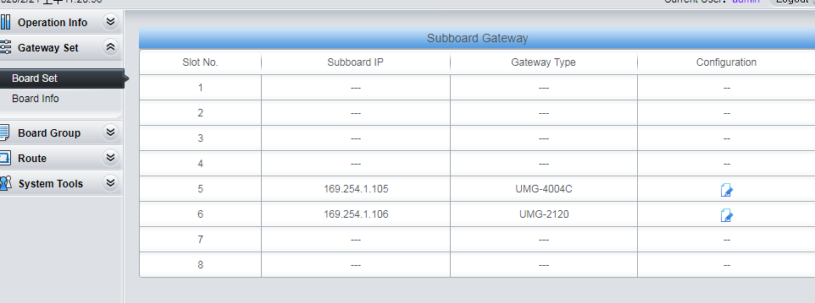

Steps:

1. Create Board Group for Sub-Boards.

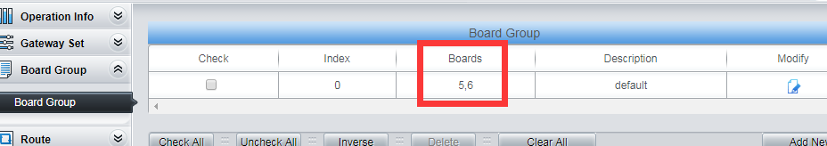

1. Add IP>TEL routes at main board.

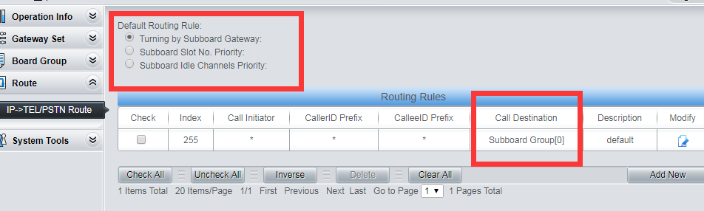

Ps:

Turning by Subboard Gateway: means incoming calls will land to subbords evenly.

Subboard Slot No.Priority: means incoming calls will land to Board 5 first, if Board 5 has no idle channels, calls will go to Board 6. The smaller the index of the subboard, the higher the prioriy.

Subboard Idle Channels Priority: Means calls will land to subboard which has the most idle channels first.

Setting on Wireless(Analog) suboard:

1. Jump to wireless suboard from main board,

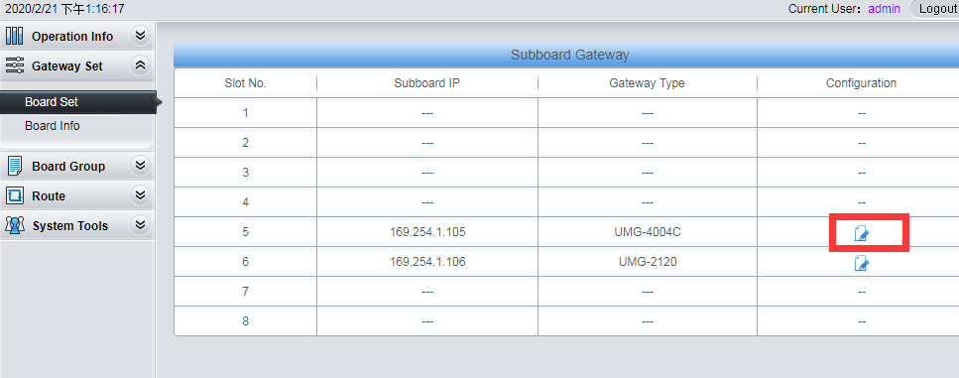

1. Create port group

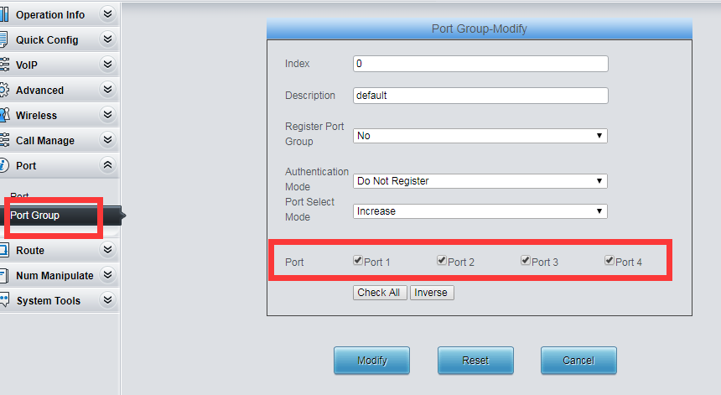

1. Set incoming route(IP>TEL)

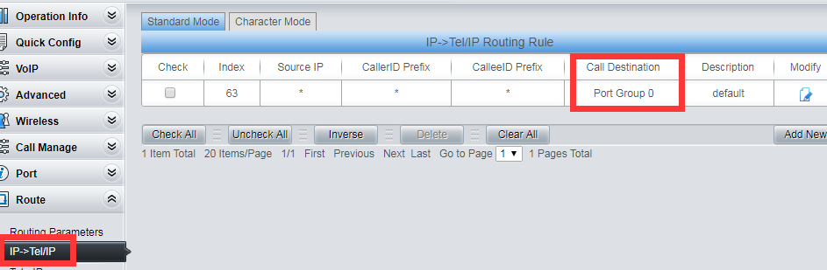

1. Set outgoing route(TEL>IP)

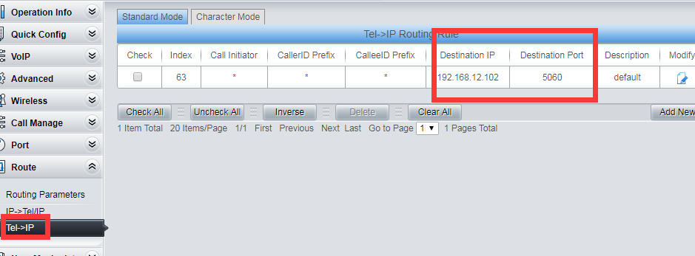

Set the destination ip and port here.

Done

Setting on Digital subboards:

1. Jump to digital subboard from main board.

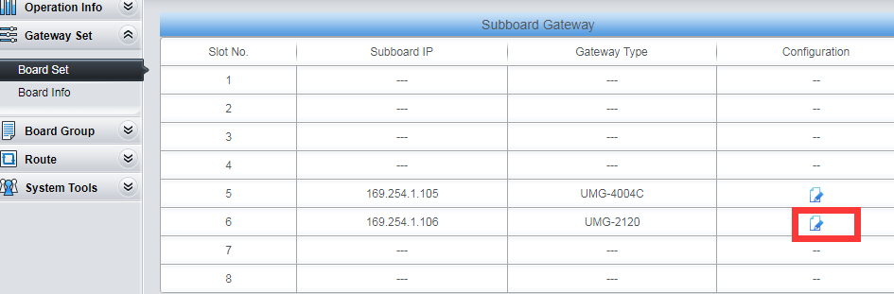

1. Add SIP trunk.

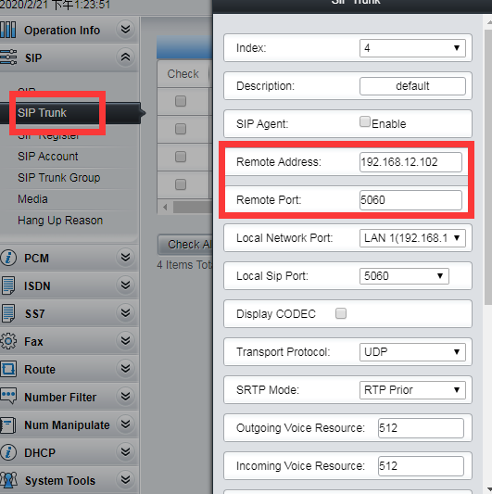

1. Add Sip trunk group for sip trunk.

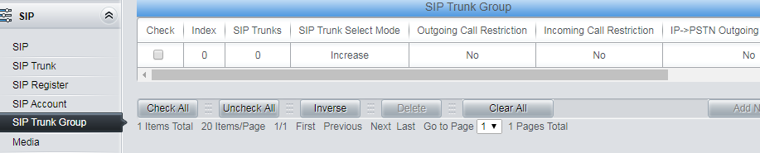

1. Add PCM trunk.

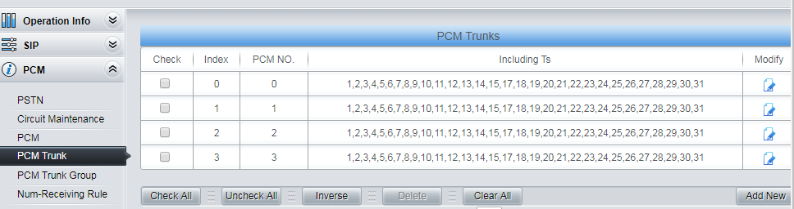

1. Add pcm trunk group

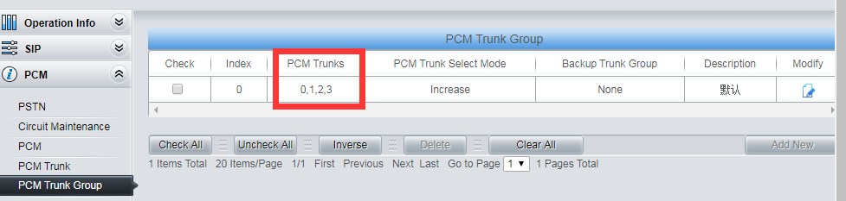

1. Add Incoming route(IP>PSTN)

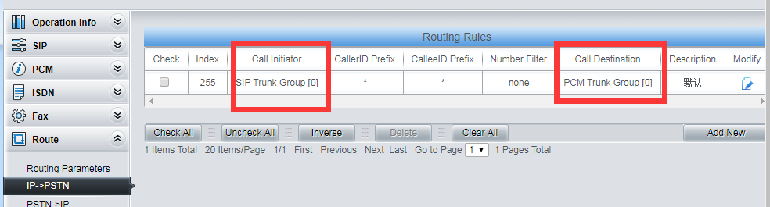

1. Add outgoing route(PSTN>IP)

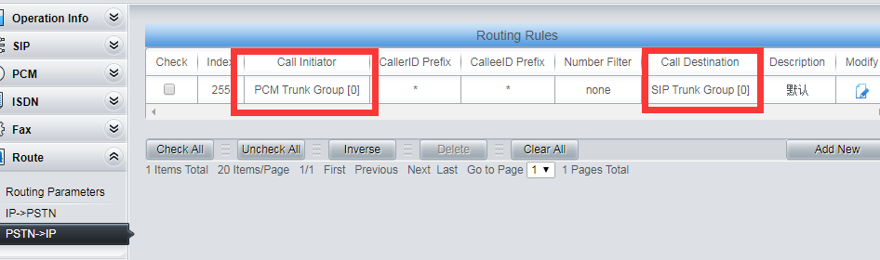

Done.